
Experiences and Outcomes: Traditional Rhymes – 9th September – 26th September

Numeracy & Mathematics | Literacy & English | Sciences | Expressive Arts | Additional children’s planning
Number, money and measure | Reading | Materials | Music
Rhyme Time  All Children  Explore sound bags  Identify and name each item.  Does it rhyme?  Work out which words sound the same and different.  Play matching game,  Take turns to find rhyming items.  Younger Children  Explore, name, sound and tap out syllables  Pre-school –  Explore, name, sound, tap out syllable and discover rhyming words.  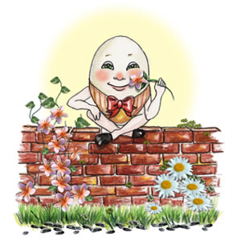  I can match objects, and sort using my own and others' criteria, sharing my ideas with others.  MNU 0-20b | 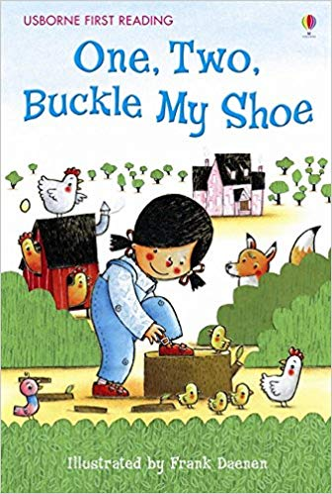  And  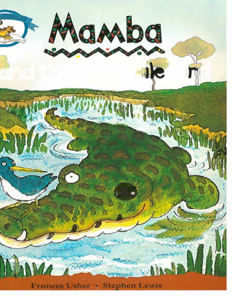  I enjoy exploring and playing with the patterns and sounds of language, and can use what I learn.  LIT 0-01a/LIT 0-11a/LIT 0-20a | Record weather/Make weather chart  Have daily discussions with the children about the weather, discussing temperature and season.  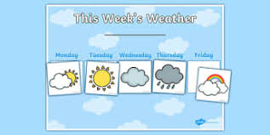  Explore appropriate clothing for variable weathers.  Conduct weather reports recording with the new cameras and review together.  Revisit Calendar months song and days of the week and discuss seasons.  I enjoy taking photographs or recording sound and images to represent my experiences and the world around me.  TCH 0-04b  I have knowledge of planting and growing.  I have helped to grow plants and can name their basic parts. I can talk about how they grow and what I need to do to look after them.  SCN 0-03a | What’s in the magic box?  Revisit rhymes and props box.  Provide a variety of instruments and decide which instruments suit the chosen rhyme.  Encourage children to use their voice, musical instruments and movement to enjoy playing with sound and rhythm.    I have the freedom to use my voice, musical instruments and music technology to discover and enjoy playing with sound and rhythm.  EXA 0-17a | Additional Ideas  From your children  “Make a gingerbread man, we will need icing.” Alison  “Build a wall for humpty.” Ellise Anne  “We could play pass the egg.”  Lewis  “Make and hang a star on the wall.” Rumor  “We could make lots of eggs.” Adam S  “Make telescopes to see the stars, use cardboard, paint and tape.” Lucas  Through contributing my views, ideas, time and talent I play a part in the creation of our curriculum  HWB 0-13a  My views are respected.  Through contributing my views, time and talents, I play a part in bringing about positive change in my school and wider community.  HWB 0-13a
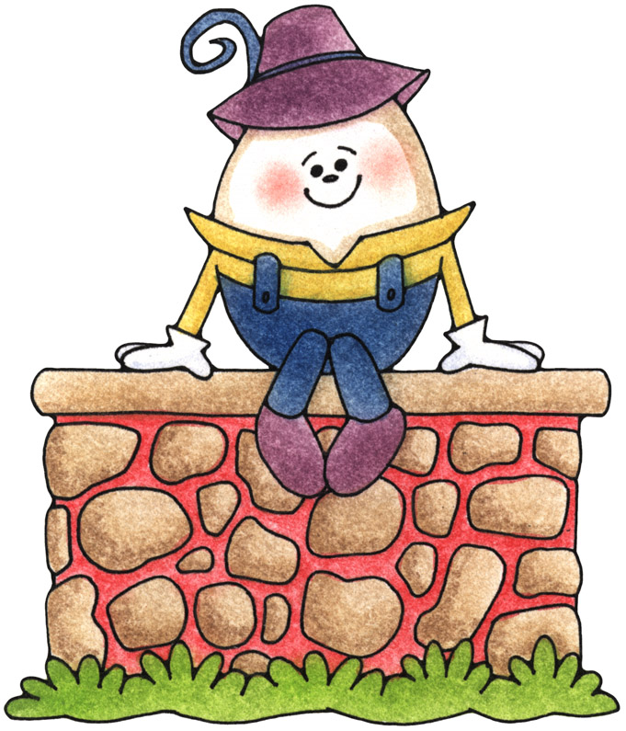
Experiences and Outcomes: Traditional Rhymes – 9th September – 26th September

Religious and moral education | Technologies | Social Studies | Health and Well being | Reflection
Respect |  |  |  | Big Book
Full of feelings  Gather for circle time to explore the egg expressions box set, read the story and discuss the characters feelings using egg props.  Encourage the children to share real life experiences and how they felt at the time.  Revisit Our Golden Rules.  As I play and learn, I am developing my understanding of what is fair and unfair and the importance of caring for, sharing and co-operating with others.  RME 0-02a | In the Orchid  Introduce the Orchid in the nursery garden.  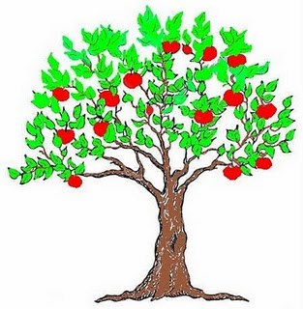  Discuss where foods come from under and over ground.  Collect and prepare apples.  Follow recipe to make an apple crumble.  Relate to “Sing a song of sixpence.”  I explore and discover where foods come from as I choose, prepare and taste different foods.  HWB 0-35a | Play dough Spiders  Create Incy Wincy spiders from playdough use props, pictures and books to learn about spiders.  Search the garden for webs.  Cook models in the oven, paint and decorate with a variety of media.  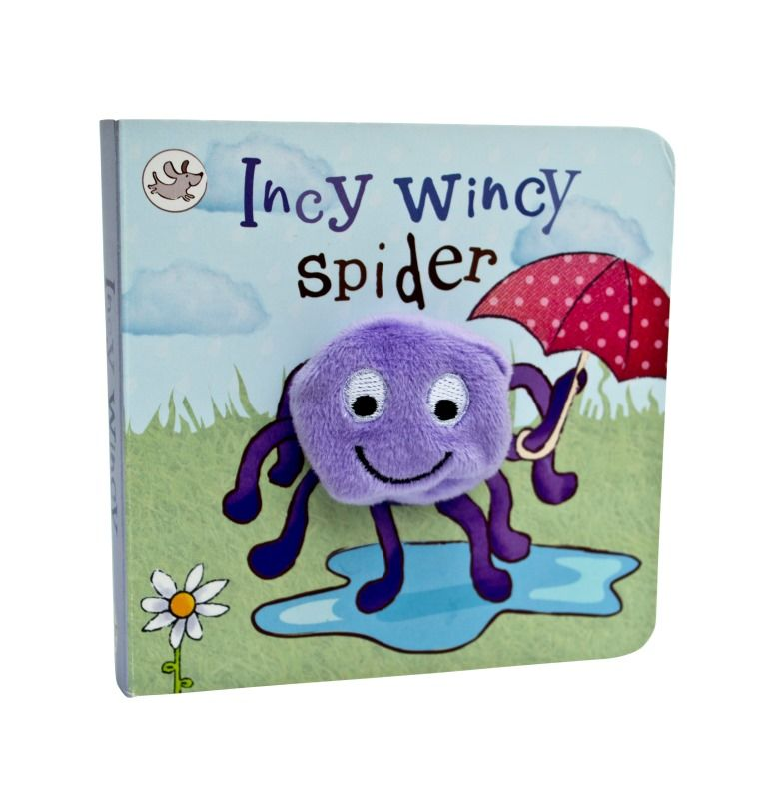  www.youtube.com/watch?v=YAJynCIsNUg  I explore and appreciate the wonder of nature within different environments and have played a part in caring for the environment.  SOC 0-08a | Time Mat  Hickory Dickory Dock  Set up the time floor mat. Talk about the clock and what it is for.  Each child takes a turn of being the mouse walking around the clock stopping at 1,2,3,4 or 5 doing the action that goes with that number.  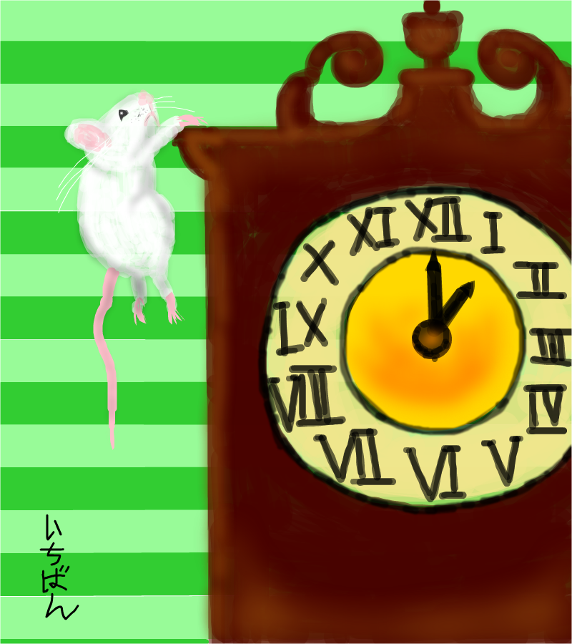  The clock struck 1 the mouse ran down.  2 the mouse went boo.  3 the mouse went weeeeeee.  4 the mouse sat on the floor.  5 the mouse took a dive.  I am learning to move my body well, exploring how to manage and control it and finding out how to use and share space.  HWB 0-21a | Reflection  Throughout this topic continually discuss and reflect on the learning that is occurring.  Make additions to big book planning and complete learning logs at the end of topic.  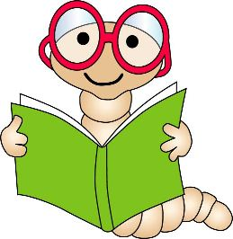  As I play and learn, I enjoy exploring interesting materials for writing and different ways of recording my experiences and feelings, ideas and information.  LIT 0-21b
Outdoor Classroom Experiences and Outcomes: Traditional Rhymes – 9th September – 26th September

Monday Madness | Literacy | Numeracy | Health and Well Being | Fun Friday
 |  |  |  | Observations
Mindful Monday  Adult led activity working in various areas of the outdoor classroom - tidy up put things away ready for another day.  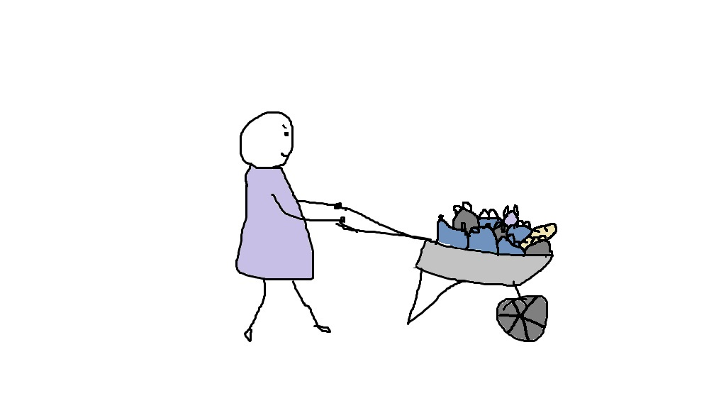  Encourage children to use brushes, wheelbarrows and baskets for sweeping, collecting and transferring and dumping.  Check and sort resource boxes/Shelves.  Bike wash.  Wash and tidy up mud kitchen.  Clean chalk boards and easels.  I explore and appreciate the wonder of nature within different environments and have played a part in caring for the environment. SOC 0-08a | Ring Games  “Little Miss Muffet”  Gather in a circle one child plays Miss Muffet sitting on a cushion in the centre of the circle with a bowl and spoon, one child plays the spider creeping up to sit on the cushion next to Miss Muffet giving her a fright the spider runs round the circle after Miss Muffet and then becomes miss Muffet for the game to begin again.  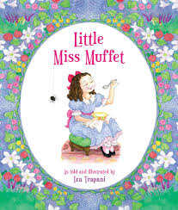  I enjoy exploring events and characters in stories and other texts, sharing my thoughts in different ways.  LIT 0-01c | Egg and spoon race  Explain the rules of the sports event.  Talk about balance, movement, speed, and finishing position, winner and runners up.  Half of the team race while the other half cheer their team mates on.  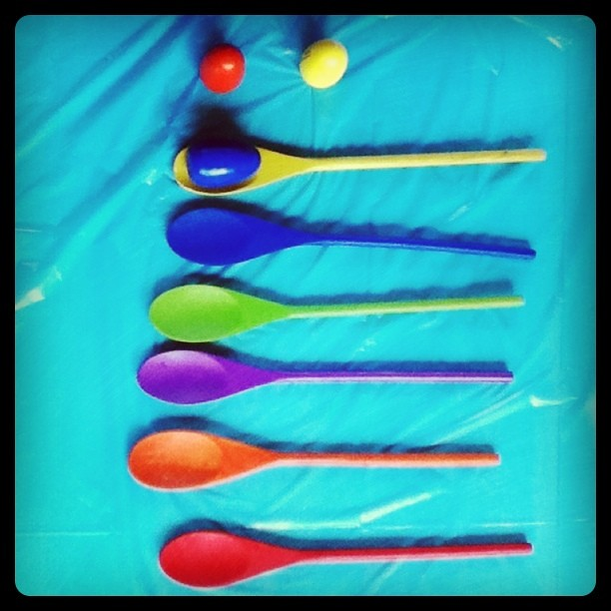  In movement, games, and using technology I can use simple directions and describe positions.  MTH 0-17a | Follow the leader  Mary had a little lamb.  While saying the rhyme each child takes a turn to be the leader using movements of their choice the rest of the group follow on copying the leader’s movements.  The leader then chooses someone to take the lead role.  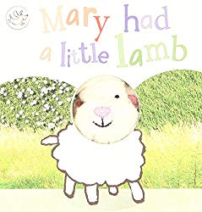  I make full use of and value the opportunities I am given to improve and manage my learning and, in turn, I can help to encourage learning and confidence in others.  HWB 0-11a | Independent Play  Children can select where they wish to play.  Adults will monitor and support the learning where the opportunity presents itself.  Children can choose from  Bikes  Footballs  Bats/Balls  Large construction  Ring Games  Parachute  Digging/Exploring  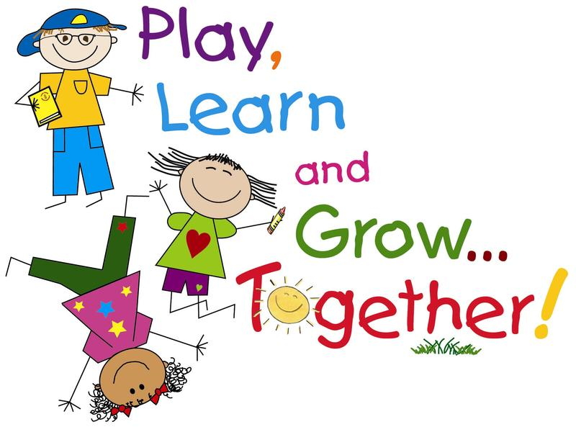  I value the opportunities I am given to make friends and be part of a group in a range of situations.  HWB 0-14a

Traditional Nursery Rhymes

Welcome to the new term and our first planning booklet of the year.
This you will receive this once every four weeks by email and also in hard copy.

This booklet allows you to have a discussion with your child about all the activities they participate in during their time in nursery school – normally they would tell you they just played or nothing!

Traditional Rhymes are fun and rhyme is an important part
of our language and literacy programme.

We will make our Rhyme and Poetry booklet available in the
playroom for a nominal £1.00 purchase.

The Books we are using during this period, One two Buckle
my shoe and Mamba and the Crocodile Bird can also be
borrowed from the local library – Maryhill or Hillhead.

Any queries, questions or suggestions please feel free
to come and see me or email me.

Gillian email: Headteacher@belhaven-nursery.glasgow.sch.uk

