Experiences and Outcomes: “The Gruffalo Explores Numbers” 17th February -27th March 2020
Numeracy & Mathematics | Literacy & English | Sciences | Expressive Arts | Additional children’s planning
Number, money and measure | Reading | Materials
“Make our own snake” Beatrice  “Snakes, sizes - Ava  Pasta Snakes  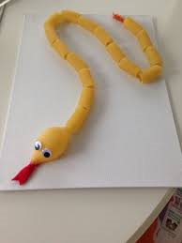  Provide 4 bowls with 10/20 pieces of pasta and children can decide on amounts they want to thread on to individual ribbon.  Encourage and support counting (NT)  - Discuss what zero represents  - Count forward/backwards 0-10  - Recognise numbers (“point to number 7, 10”)  - Identify random number by name not rote counting “What number is this”  Use mathematical language appropriate to situation  More, less, big, bigger, biggest, small, smaller, smallest, height, length etc.  I am developing a sense of size and amount by observing, exploring, using and communicating with others about things in the world around me. MNU 0-01a | “I like the gruffalo, he is big” Rayyan  “I want to learn about the gruffalo” Beatrice  The Gruffalo  Introduce the story to the children with the prop characters exploring the roles of the author, illustrator and language and layout of book.  Read book and reflect on characters and morals within the story.  Explore sequence of animals – who did he meet first, next? Where did they live?– Fox-underground, Owl-tree top, Snake-logpile, Gruffalo-wood  Why do the animals want the mouse to join them in their houses?  Recall descriptive language used about the Gruffalo  Terrible Tusks, claws, jaws  knobbly knees, turned out toes, poisonous wart,eyes orange, tounge black, purple prickles  Who were the creatures actually frightened of? Mouse or Gruffalo?  As I listen and talk in different situations, I am learning to take turns and am developing my awareness of when to talk and when to listen. LIT 0-02a/ENG 0-03a | “Gruffalo Crumble” Ingrid/Eli  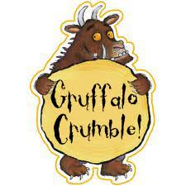  We use all our senses to bake  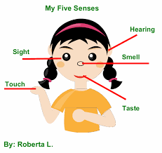  We are looking at ingredients, listening to instructions, touching and smelling ingredients and will taste once complete.  Follow usual hygiene practise in preparation for baking.  Explore recipe, ingredients and utensils.  Follow recipe to create crumble counting, measuring etc.  I can identify my senses and use them to explore the world around me.  SCN 0-12a | “Make a Gruffalo” Owais /Ethan/Georgie/Jessica  Grufallo Creations  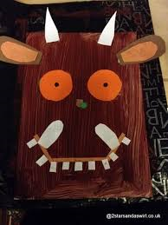  Provide a selection of materials to create individual/group creations  Large boxes, ribbons, shapes, paint, glue etc.  In addition to this children can make individual masks of which character they prefer  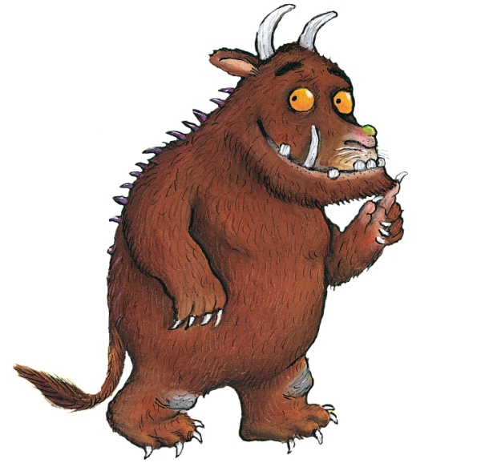  “Make a Gruffalo Mask” Alison  Inspired by a range of stimuli, I can express and communicate my ideas, thoughts and feelings through activities within art and design. EXA0-05a | “Make Gruffalo soup” Clarke  “Make Roasted fox” Erin  “Find numbers” Nathanial  “Numbers on the measuring tape” Ariana /Edwin  “He’s friendly with the mouse” Elsa  “We could make Owl Ice Cream” Kasper  “Make a Gruffalo house” Fern  “Make a fox” Willa  “I like counting to 100” Lewis  “We could do a Gruffalo trail and follow the footprints” Ridley  “Go to the meadow and find the Gruffalo” Ania  “Use boxes for Gruffalo cave”  Representing my class, school and/or wider community encourages my self-worth and confidence and allows me to contribute to and participate in society. HWB0-12a

Experiences and Outcomes: “The Gruffalo Explores Numbers” 17th February -27th March 2020
Religious and moral education | Technologies | Social Studies | Health and Well being | Reflection
Cultures | Technological development in society | People, place and environment | Physical Wellbeing | Big Book
“Snakes and Ladders with a dice” Tabitha /Greta  Introduce this traditional game to the children with emphasis on the rules of climbing up the ladders and sliding down the snake  Explain the dice represents which amount the counter is allowed to move  Awareness of instant recognition of amount on dice without counting dots (subitising}  Reinforce turn taking, counting and directions  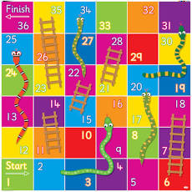  As I play and learn, I am developing my understanding of what is fair and unfair and the importance of caring for, sharing and co-operating with others. RME 0-05a | “Make green/purple jelly”Lucas/Sam  Provide fruit which represents colours associated to the Gruffalo  His eyes are orange – Mandarins  His tongue is black – Blackberries  He has purple prickles –Blueberries/grapes  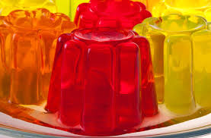  Follow jelly instructions, watch the granules dissolve, discuss liquid form and change once set.  Together we enjoy handling, tasting, talking and learning about different foods, discovering ways in which eating and drinking may help us to grow and keep healthy.  HWB 0-30a | “Count the Gruffalos big sharp teeth” Logan /Mokshith  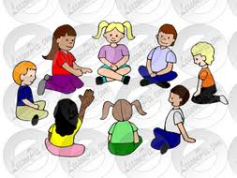  Circle Time  Sing Hello everyone  Join hands with friends and pass smile round the circle  Introduce the Gruffalo Puppet and his friend T-Rex with their big teeth and smile.  Reflect on his “terrible jaws” from the story and who could he visit to take care of his teeth?  Count both sets of teeth, who has more/less etc.  Discuss individual visits to the dentist – Mamba story available for breadth of task.  By exploring my local community, I have discovered the different roles people play and how they can help.  SOC 0-16a | “Draw scary faces” Sean  Show scary faces”Peggy  Game Eggpressions – Explore Feelings  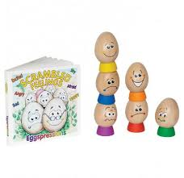  Reflect on Gruffalo story and how people feel about him.  Introduce feelings eggs and explore associated emotions with story.  Describe events that can occur that may have related emotions such as birthdays make you happy  missing someone makes you sad etc.  I know that we all experience a variety of thoughts and emotions that affect how we feel and behave and I am learning ways of managing them.HWB 0-02a | Reflection  Throughout this topic continually discuss and reflect on the learning that is occurring.  Make additions to big book planning and complete learning logs at the end of topic.  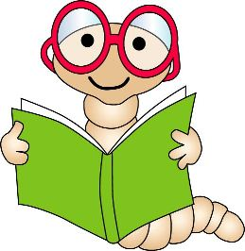  As I play and learn, I enjoy exploring interesting materials for writing and different ways of recording my experiences and feelings, ideas and information LIT 0-21b

Outdoor Classroom Experiences and Outcomes: “The Gruffalo Explores Numbers” 17th February -27th March 2020
Monday Madness | Literacy | Numeracy | Health and Well Being | Fun Friday  Observations
Mindful Monday  Adult led activity working in various areas of the outdoor classroom - tidy up put things away ready for another day.    Encourage children to use brushes, wheelbarrows and baskets for sweeping, collecting and transferring and dumping.  Check and sort resource boxes/Shelves.  Bike wash.  Wash and tidy up mud kitchen.  Clean chalk boards and easels.  I explore and appreciate the wonder of nature within different environments and have played a part in caring for the environment. SOC 0-08a | Soft Play Visit –  Re-enact the Gruffalo  Discuss soft play rules  - Shoes off  - Tuck away shoes  - Timer on  - Spatial awareness of peers  - Level of volume awareness  Revisit the story in soft play and allocate roles to each child.  Move around the area reciting the story – have fun –switch roles  Replicate the movements of the creatures  Big stomping – Gruffalo  Tippy Toes – Mouse  Slithering – Snake  Flapping - owl  Creeping – Fox  Have fun  I enjoy exploring events and characters in stories and other texts and I use what I learn to invent my own, sharing these with others in imaginative ways.  LIT 0-09b/LIT 0-31a | “Gruffalo hunt in the garden” Adam/ Orla /Brody/Sara  Explain that there are Gruffalos hidden in the garden and we need to go on a gruffalo hunt to find them. We must search high and low to gather them all…….  - We must look down low to the underground house  - Up high for the tree top house  - Search the log pile house  Once collected count the amount of Gruffalos found  Replace with a mask alternative for each child to decorate or to take home if they wish  In movement, games, and using technology I can use simple directions and describe positions. MTH 0-17a | Hide and Seek  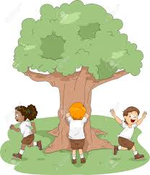  Remind the children of the rules associated to the game –  Adult will be seeker to begin with  Amount to count to can be agreed with the group  Children will hide and adult will seek  Take turns to be seeker  Additional games can be explored such as  What the time Mr Gruffalo?  Walking in the forest who do I see?  Mouse, Mouse, Gruffalo  I am developing my movement skills through practice and energetic play.  HWB 0-22a | Independent Play  Activity Hut  Water wall  Chalkboards  Pirate ship  Sand  Bikes  Mud Kitchen  Music Area  Sand Pit  All adult led activities are available for children to opt in where they choose to  Provide Parachute games  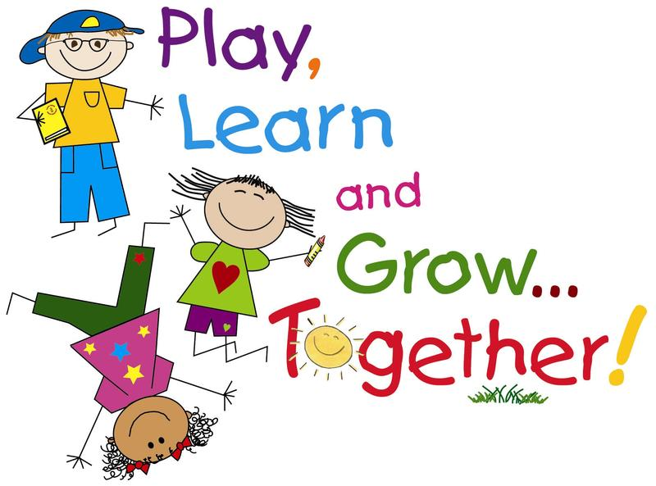  I value the opportunities I am given to make friends and be part of a group in a range of situations. HWB 0-14a

____________________________________________

The Gruffalo Explores Numbers

Dear Parents and Carers

The children displayed an interest in both numbers and The Gruffalo which led to a vote. It was a close ballot therefore we decided we would blend the topic and extend the learning over a slightly longer period -17th February to 27th March,

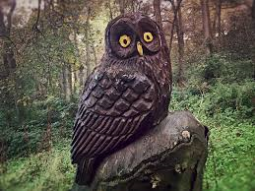
Locally, you can visit the Children’s wood and North Kelvin Meadow and create your own Gruffalo Trail or alternatively a little further afield visit
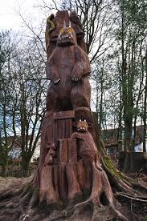
The Gruffalo trail
Bearsden, Glasgow G613NW

There are lots of materials available online to extend the learning at home,
Any photographs please send to Headteacher@belhaven-nursery.glasgow.sch.uk

